Retrieving or Re-Activating an Archived File

- Log In to ProWorks

- Scroll down to the bottom of the main dashboard page and select View All

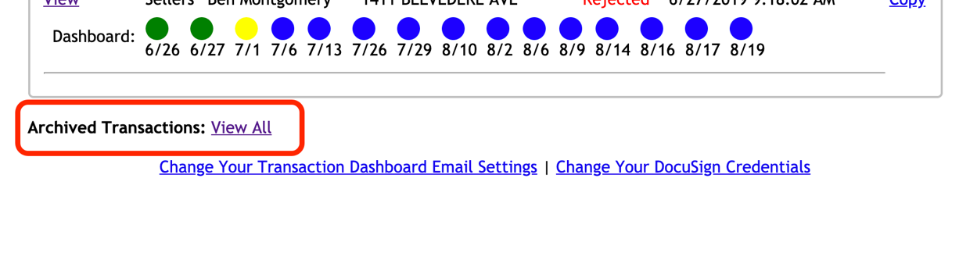

- Enter the Street Name attached to the file

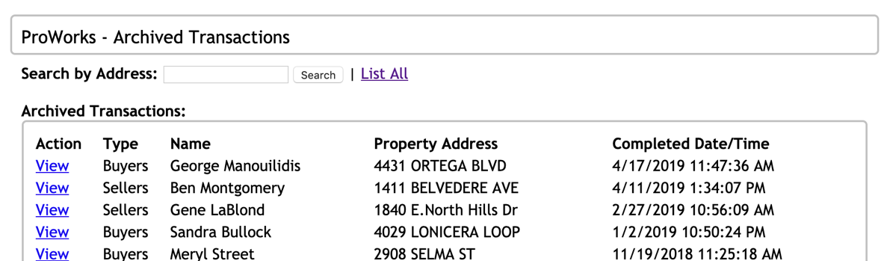

- Select to View the transaction

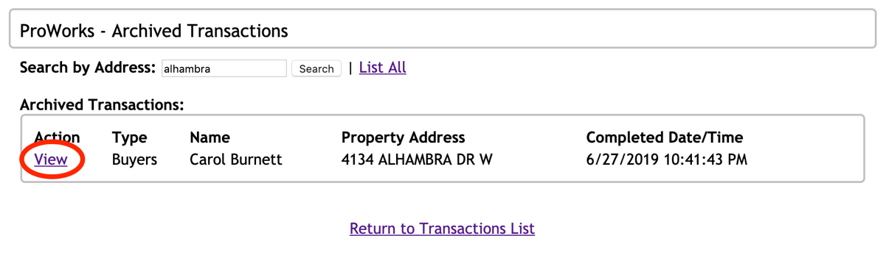

- Within the transaction dashboard, scroll to the bottom of the page and select to Unarchive Transaction

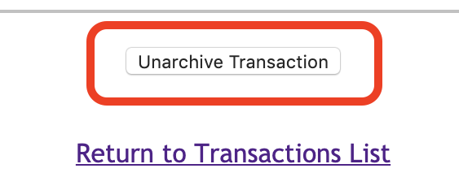

This will place the transaction back into the Existing Transactions block of the ProWorks Dashboard

